Virtual Box
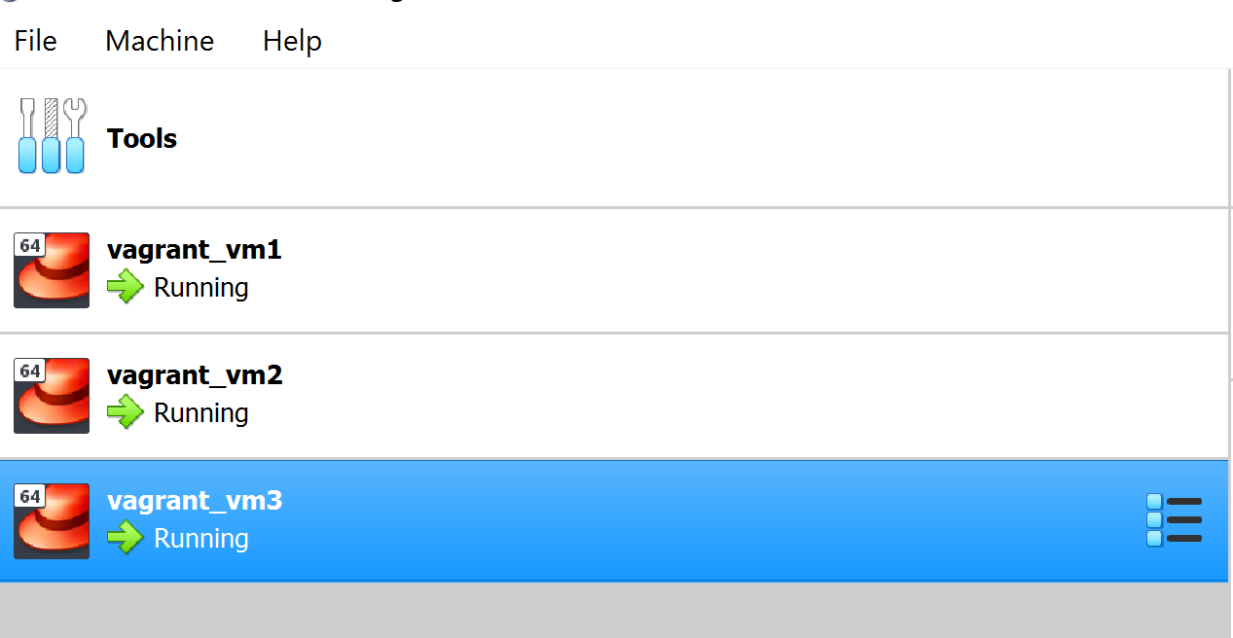

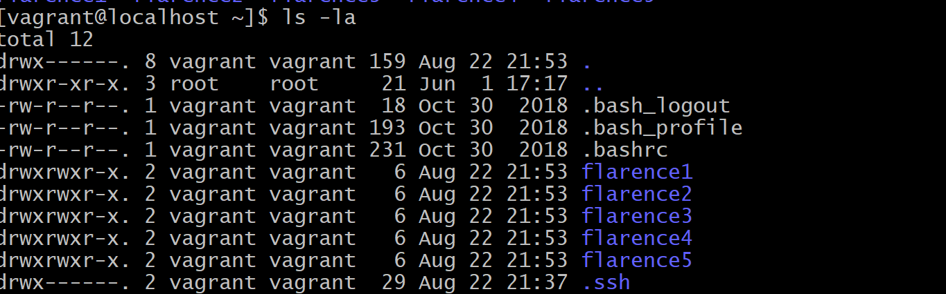

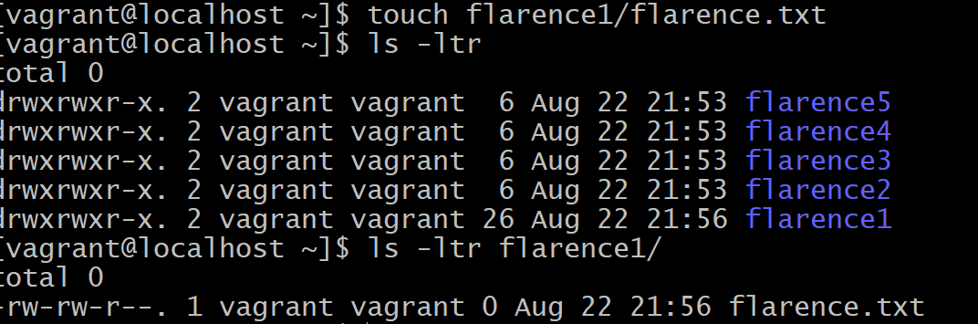
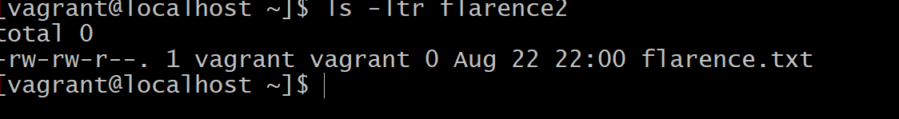
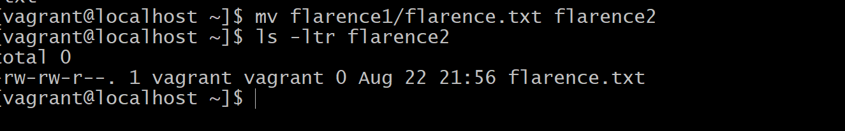
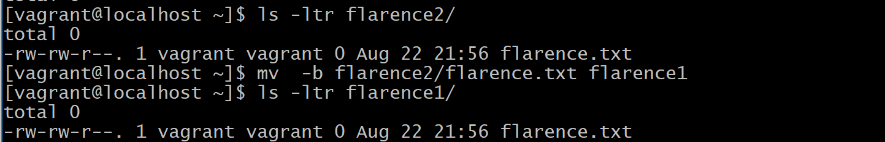
rm
-i
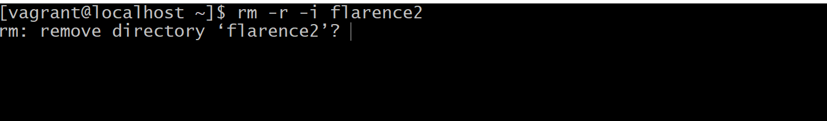
ln
-s
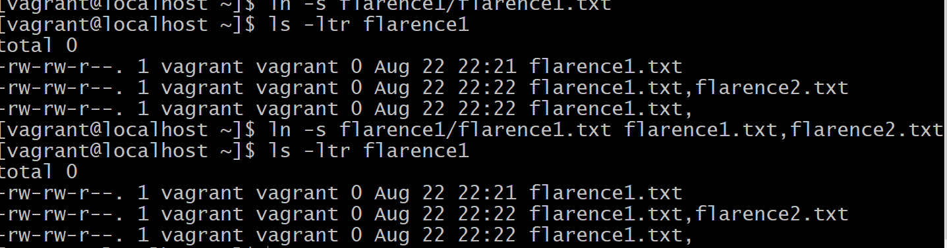
Cd
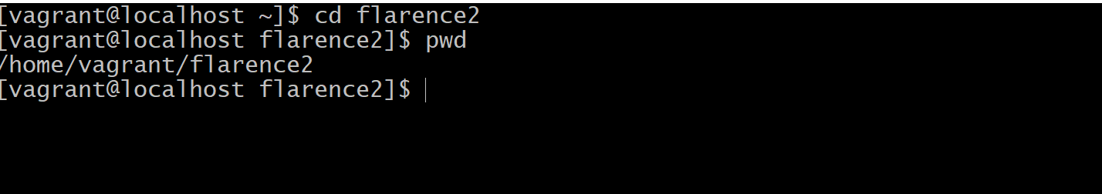
mkdir
rmdir
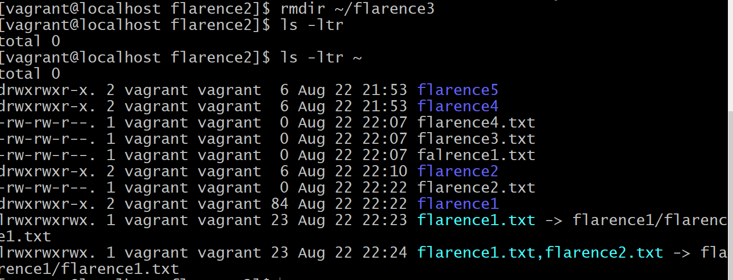
Chown
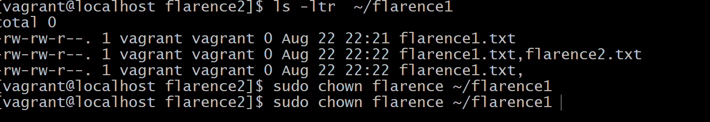
chmod
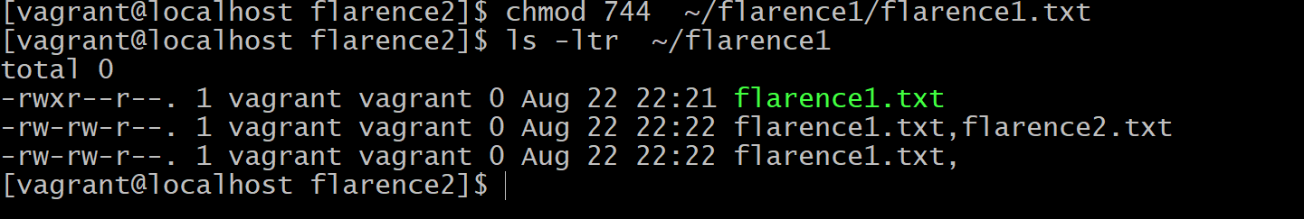
tar
find
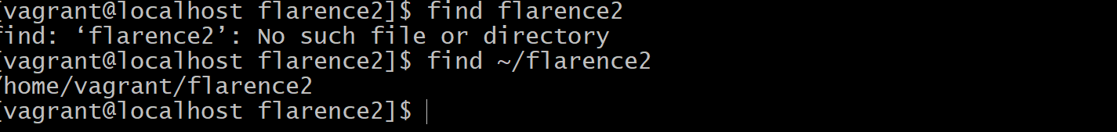
cat


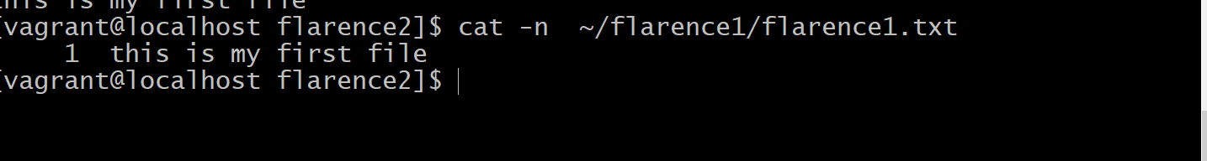
less

grep
-i

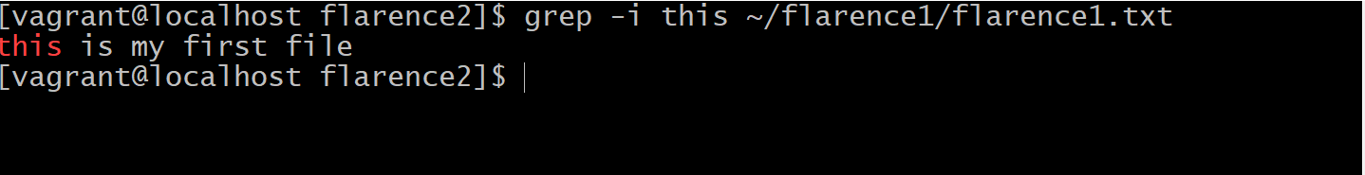
-l
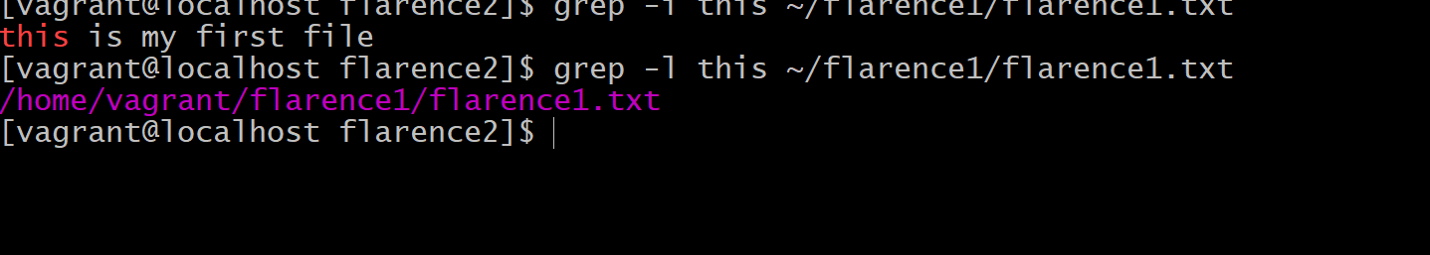
-n
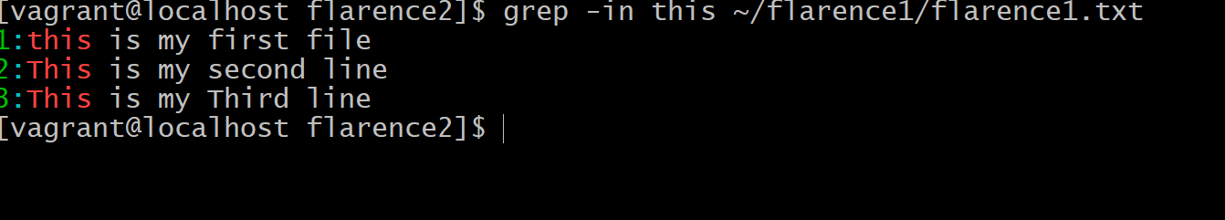
-l
Only lists the files in which searchstring does not occur
diff
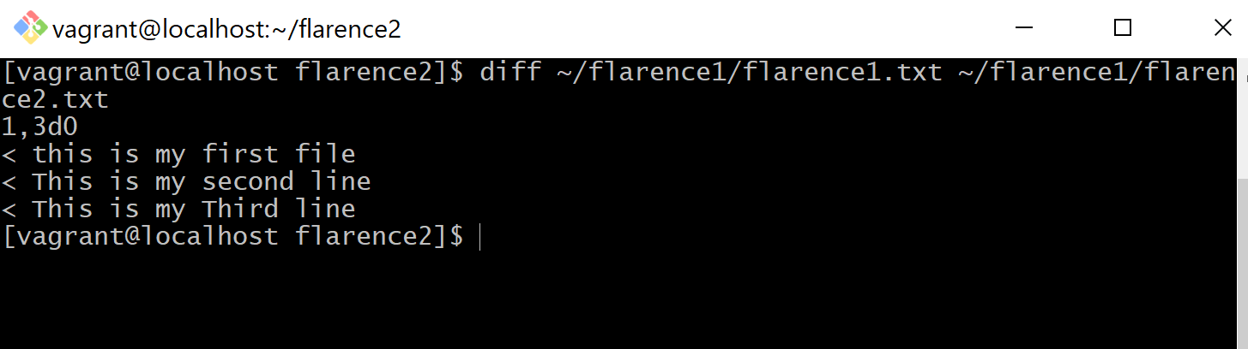
df
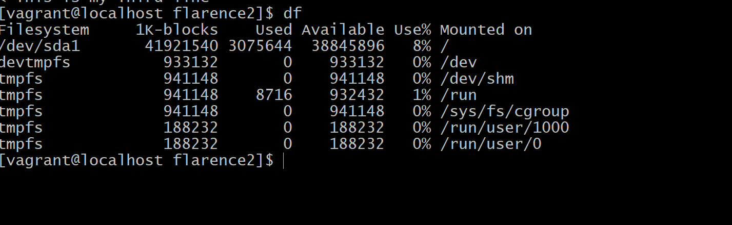
-H
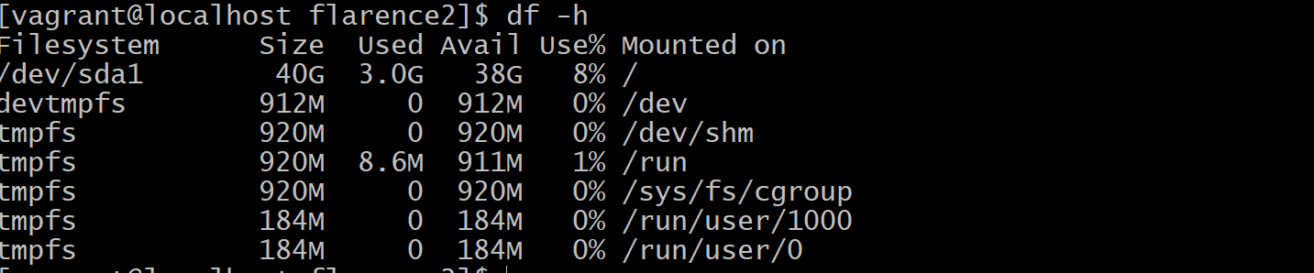
-t
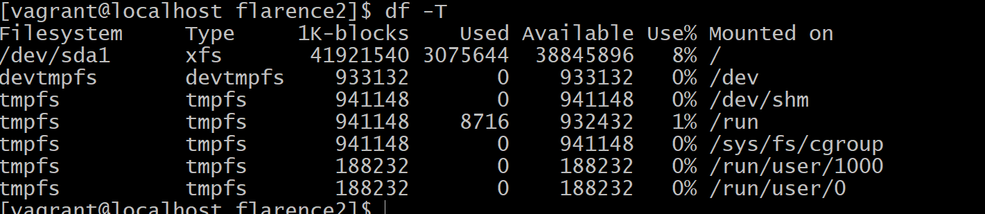
du
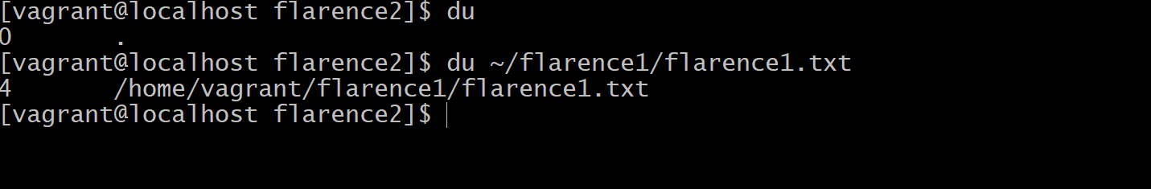
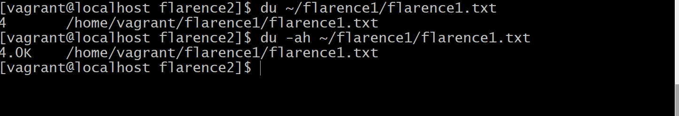

-s
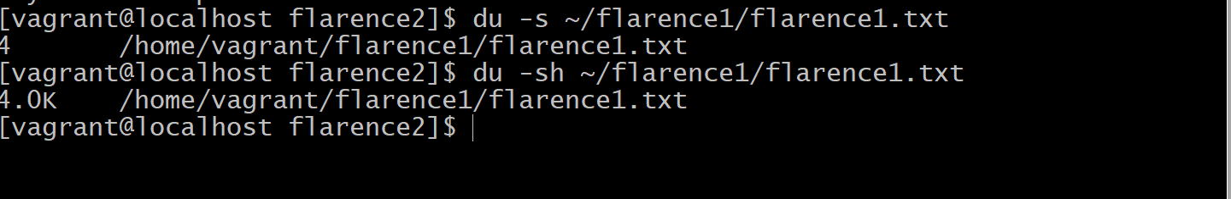
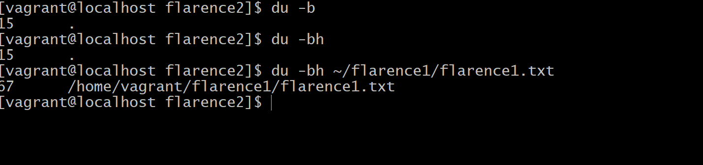
date
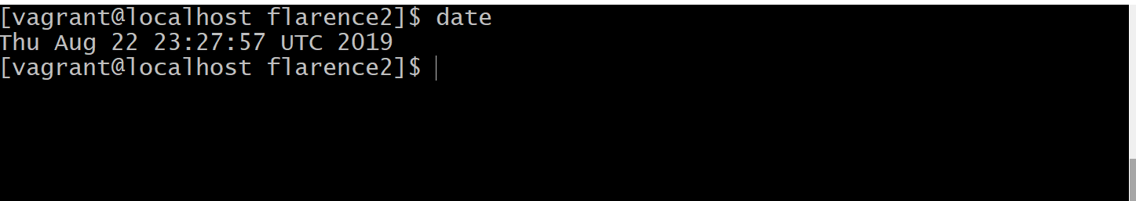

top

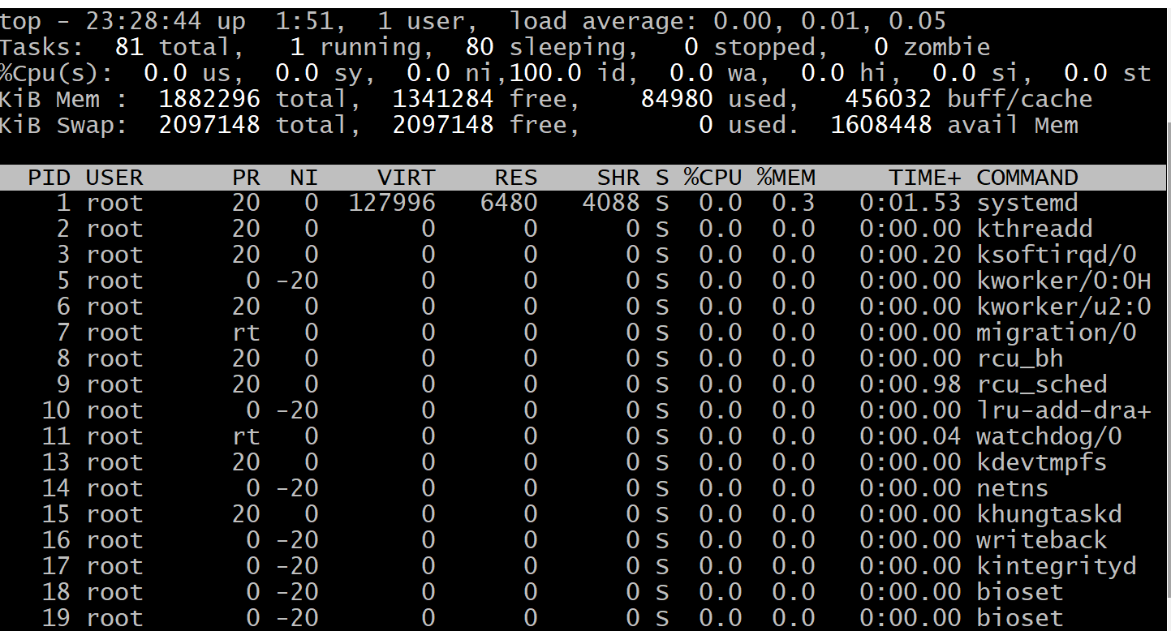
ps
aux
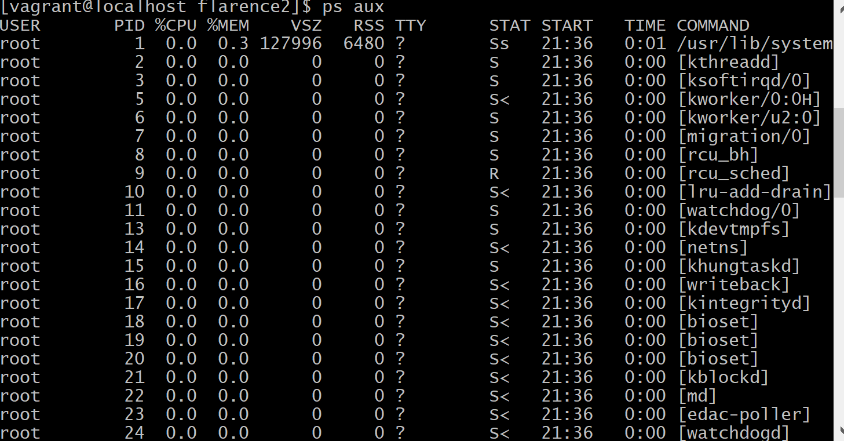
kill
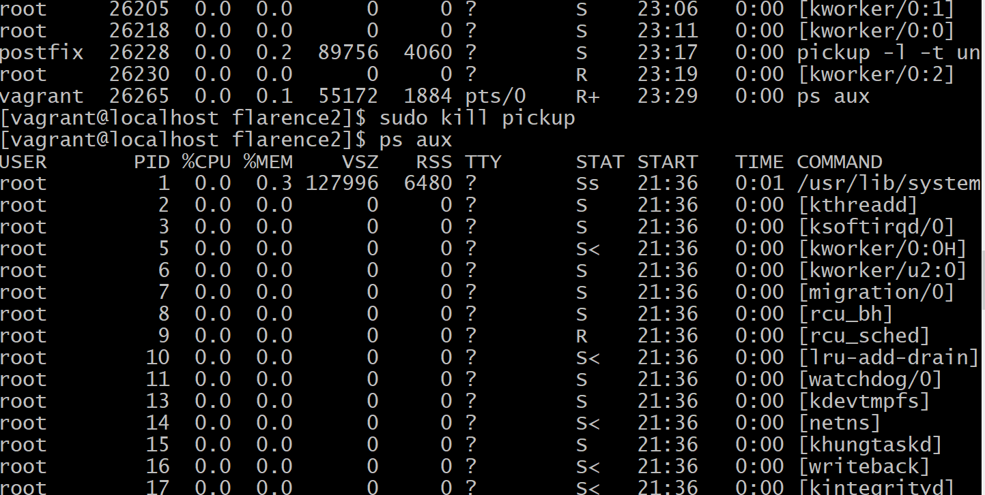
ping

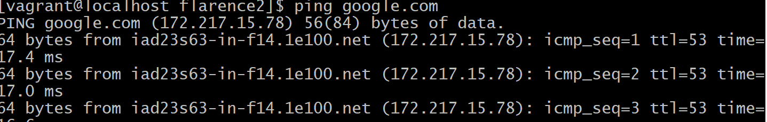
Nslookup
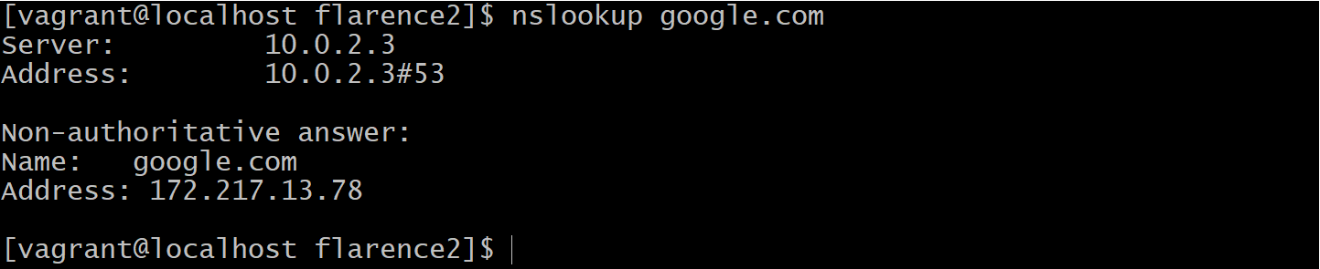
telnet
